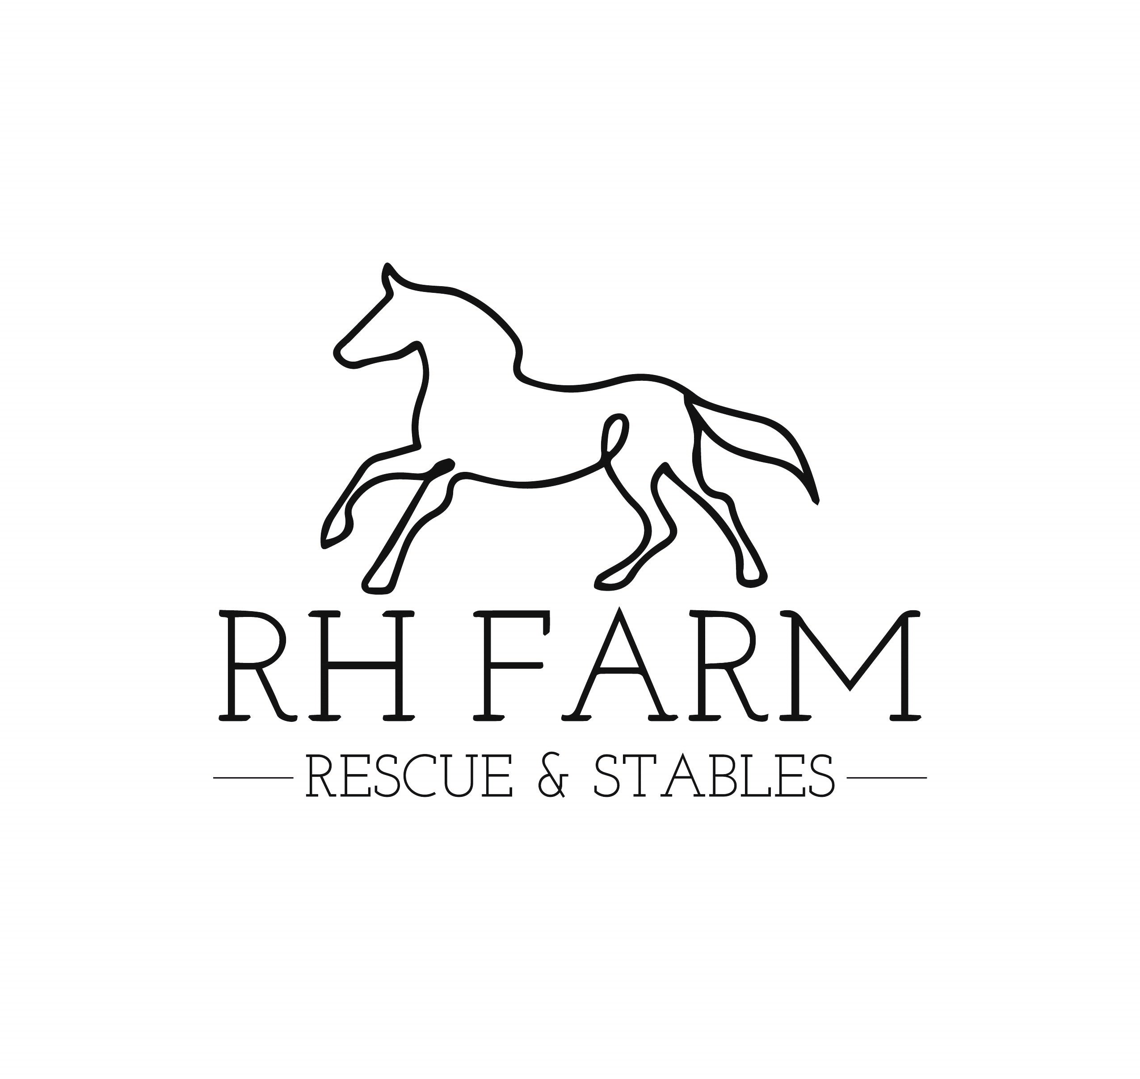

Adoption Agreement
This contract is entered into on this______day of _________, 20____between RH FARM LLC and it’s proprietor Grace Ryder (hereinafter referred to as “RH FARM”) and ___________________________________________ (hereinafter referred to as “Adopter.”)
The Adopter agrees, in accordance with the terms and conditions set forth in this Agreement, and in recognition of the terms set in their adoption application, to adopt and care for the horse known as __________________________________(hereinafter referred to as “Said Horse.’)
RH FARM / GRACE RYDER agrees to transfer ownership of Said Horse to the Adopter subject to the conditions set forth in this agreement. The Adopter understands that an adoption fee in the amount of $__________ shall be made payable to Grace Ryder. The Adopter agrees to pay for the cost of any prepurchase professional evaluations or veterinary exams contracted for by the Adopter. The Adopter agrees to pay the cost of transporting Said Horse to its new facility. The adoption fees are nonrefundable and must be paid in full on or before the day of delivery/pickup of Said Horse.
The Adopter will, at his or her expense, care for Said Horse in a responsible and humane manner. RH FARM guidelines for care of Said Horse include, but are not limited to: adequate shelter, feed, turnout, worming, farrier, veterinary, and dental care. Horses requiring professional training must make advancements in skill. The Adopter promises to NEVER allow Said Horse to be sold at any auction or put at risk for slaughter, including selling to a horse dealer/reseller. In addition, Adopter agrees NOT to allow Said Horse to race. In the event Adopter fails to adhere to these guidelines or Said Horse becomes neglected or abused in the opinion of an independent professional, this agreement is void, and Said Horse will be immediately returned to RH FARM at the expense of the Adopter.
Adopter understands that all known veterinary records will be provided to Adopter, and understands that Said Horse may need updated vaccinations, worming, dental, and farrier care.
Adopter understands that there many be unobserved health conditions of Said Horse, and RH FARM cannot know all of the details of Said Horse’s history. The responsibility for determining if Said Horse is fit for use by Adopter belongs solely to Adopter. Adopter acknowledges that Adopter has been advised by RH FARM to engage the services of a licensed veterinarian and an experienced horseperson prior to adoption to evaluate Said Horse. Adopter agrees to accept Said Horse as is and where is.
Adopter agrees to provide a minimum of two (2) updates on Said Horse at 6 months and 12 months from the above date. Updates must include 1 side photo and 1 front photo, to be received via email at rhfarmstables@outlook.com. Horses adopted requiring a professional trainer must have monthly written updates until 6 months have passed from adoption date. Adopter allows RH FARM to publish pictures and progress reports on Said Horse in written and/or electronic form.
Adopter agrees to hereby indemnify and hold RH FARM and its officers, directors, and volunteers harmless from and against any and all claims, actions, damages, liability, and expense in connection with the loss of life, personal injury, and/or damage to property arising out of use or care of Said Horse.
Adopter agrees to maintain a proper nutritional program for the horse, including but not limited to, quality forage, grains, supplements, and access to fresh water at all times. I, the adopter, agree to refrain from breeding the horse. Adopter also agrees to provide satisfactory care of the horse, including, but not limited to, routine licensed Veterinary care, routine worming, farrier care, vaccinations, proper fencing and shelter, and an environment that is clean, with daily turnout space to maintain the health of the horse.
RH FARM Horse Rescue reserves the right to check on the horse periodically. The Rescue has the right and permission to send a vet of their choice to examine the horse where it is housed at any time during this period. The Rescue has the right and permission to remove any horses in Adopter's care if it is found that the horses are not being cared for as described above. No adoption fees or monies of any kind will be refunded in the event of such a removal. Registration papers, if available, will only be issued to the adopter after the adoption is finalized and the adopter has been deemed fit by the Rescue to retain ownership of the horse.
RH FARM reserves the right of first refusal (though horses may be adopted without this clause), the horse is NOT to be sold, traded, leased, or given away until full ownership is transferred. The horse is not to be used for breeding.
Adopter agrees to care for Said Horse following the terms of this Agreement and their Adoption Application for a minimum of one (1) year, at which time Adopter may decide to sell, assign or transfer Said Horse.In the event Adopter decides to sell, assign, or transfer ownership of Said Horse after the 1 year period, Adopter will notify RH FARM in writing of this intent. Upon sale, assignment, or transfer, Adopter will provide RH FARM in writing with the name, address, and phone number of new owner within 14 days of sale, assignment, or transfer of Said Horse.
Additional stipulations:
By signing below, Adopter agrees to adhere to and uphold the requirements of this contract. Neglect of any of these requirements will constitute a breach of the adoption agreement and might result in removal of the horse.

Signed_________________________________By:__________________________________Date:______________ Adopter Print Name
Signed_________________________________By:__________________________________Date:______________
Representative of RH FARM Print Name

